Supplementary Material
Supplementary information contains: Supplementary Table, Supplementary Figures and Legends.

Supplementary Table 1.
Target molecule | Antibody type | application | source
α-SMA  FN  GRP78  Occludin  TGFBR2  p- TGFBR2  SMAD2/3  p-SMAD2/3  ZO-1  GAPDH | mouse monoclonal  rabbit polyclonal  rabbit polyclonal  mouse monoclonal  rabbit monoclonal  rabbit monoclonal  mouse monoclonal  rabbit monoclonal  rabbit polyclonal  mouse monoclonal | WB, IHC  WB, IHC  WB  WB  WB  WB  WB  WB  IHC  WB | Sigma-Aldrich  Abcam  Sigma-Aldrich  Thermo Fisher  Thermo Fisher  Abcam  Santa Cruz  Cell signaling  Thermo Fisher  Millipore
α-SMA, α-smooth muscle actin; FN, fibronectin; TGFBR2, Transforming growth factor, beta receptor II; ZO-1, Zonula occludens-1; GAPDH, glyceraldehyde-3-phosphate dehydrogenase; WB, western blot; IHC, immunohistochemistry.

Supplementary Table 2.
Gene | Forward primer sequence | Reverse primer sequence
ZO-1  Occludin  FN  α-SMA  TGFBR2  SMAD2  SMAD3  Grp78  GAPDH | 5’-AAGAGA AAGGTGAAACACTGCTGA-3’  5’-TGCATGTTCGACCAATGC-3’  5’-GAGCTGCACATGTCTTGGGAAC-3’  5’- tctgtaaggccggctttgc-3’  5’- GCTGATCACCGCCTTCCA-3’  5’- ATGTCGTCCATCTTGCCATTC-3’  5’-GGAGAAATGGTGCGAGAAGG-3’  5’-CTGTGCAGCAGGACATCAAGTTC-3’  5’-CGACCACTTTGTCAAGCTCA-3’ | 5’-GGAAGACACTTGTTTTGCCAGGT-3’  5’-AAGCCACTTCCTCCATAAGG-3’  5’-GGAGCAAATGGCACCGAGATA-3’  5’-tgtcccattcccaccatca-3’  5’-CAGGTCCTCCCAGCTGATGA-3’  5’-AACCGTCCTGTTTTCTTTAGCTT-3’  5’-GAAGGCGAACTCACACAGC -3’  5’-TGTTTGCCCACCTCCAATATCA-3’  5’-GGTGGTCCAGGGGTCTTACT-3’
ZO-1, Zonula occludens-1; FN, fibronectin; α-SMA, α-smooth muscle actin; TGFBR2, Transforming growth factor, beta receptor II; GAPDH, glyceraldehyde-3-phosphate dehydrogenase.

Supplementary Figures and Legends
Supplementary Fig. 1. ER stress inhibits TGF- β2 induced EMT in RPE cells. The human RPE Cells were pre-treated with 0, 100, 200 or 300 ng/mL TM for 4h, and then treated with TGF-β2 (10 ng/mL) for another 48h. The expression of α-SMA, FN, Occludin and GRP78 proteins were analyzed by qPCR. GAPDH was used as internal control. Date was presented as mean ± SEM. n = 5/group. NS, not significant. *p < 0.05, **p < 0.01.
Supplementary Fig. 2. The effects of ER Stress on TGF-β signaling in RPE cells. The human RPE cells were pre-treated with 0 or 100 ng/mL TM for 24h, and then treated with or without 10 ng/mL TGF-β2 for another 30 min. The expression of TGF-βR2, Smad2 and Smad3 mRNAs were analyzed by real time qPCR. GAPDH was used as internal control. Date are presented as mean ± SEM. n = 5/group. NS, not significant. *p < 0.05, **p < 0.01.
Supplementary Fig. 3. High concentration of TM and TG inhibit cell survival and induces apoptosis in RPE cells. (a) The human RPE cells were treated with different concentration of TM (ng/mL) or TG (nM) for 24h, and then the cell viability was detected by MTT assay. (b) RPE cells were treated with different concentration of TM (0–300 ng/mL) for 24h, and then the cell apoptosis was detected by TUNEL assay. Nuclei are stained blue. Scale bar: 100 μm. Date are presented as mean ± SEM. n = 6/group. NS, not significant. *p < 0.05, **p < 0.01.

The following are original Western Blots:
Fig. 1A:
FN:
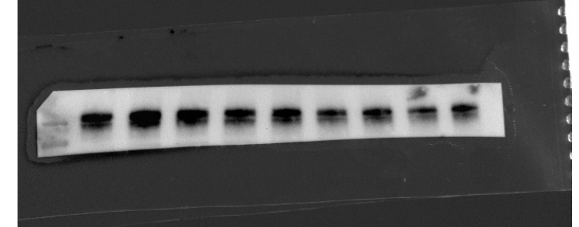
Maker ctrl 10 30 50 100 150 200 250 300
250KD
130KD
Occludin:
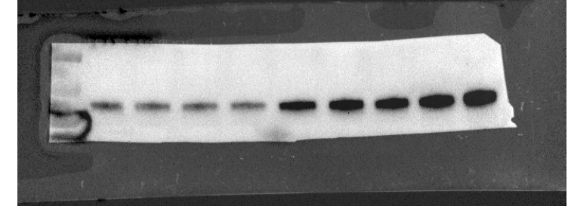
55KD
70KD
100KD
Maker ctrl 10 30 50 100 150 200 250 300
α -SMA：
Maker ctrl 10 30 50 100 150 200 250 300
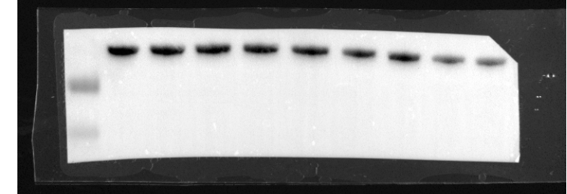
25KD
35KD

Grp78：
Maker ctrl 10 30 50 100 150 200 250 300
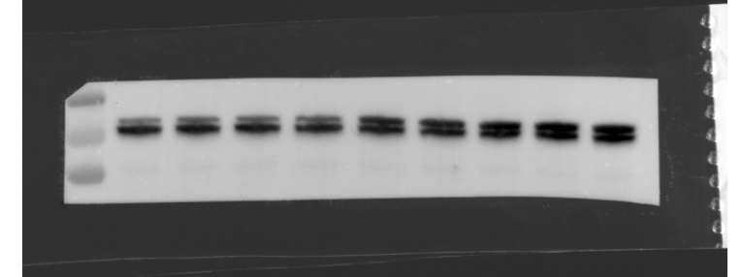
100KD
70KD
55KD

GAPDH:
Maker ctrl 10 30 50 100 150 200 250 300
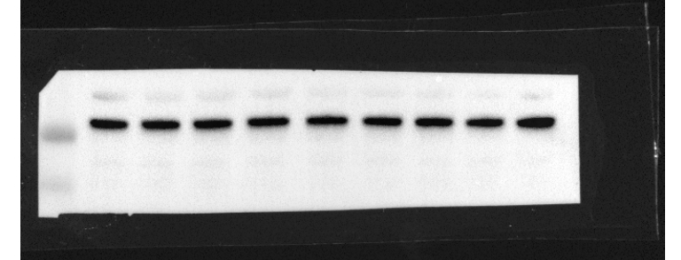
35KD
25KD

Fig. 1B
FN
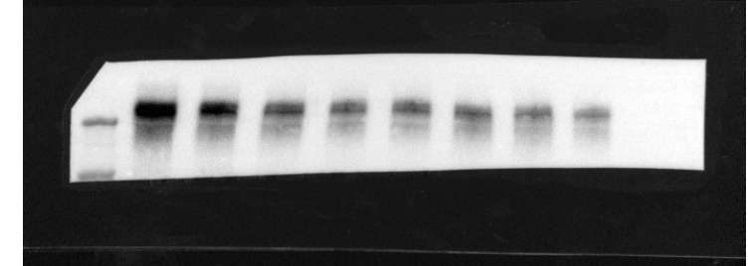
130KD
250KD
Maker ctrl 25 50 100 150 200 300 400

Occludin
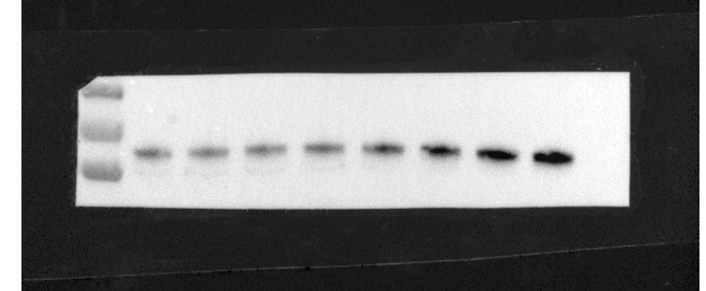
55KD
100KD
70KD
Maker ctrl 25 50 100 150 200 300 400
α-SMA
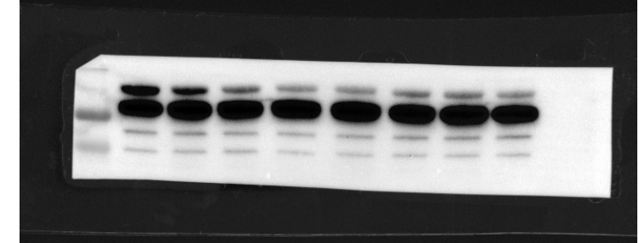
GAPDH
35KD
25KD
Maker ctrl 25 50 100 150 200 300 400
Grp78
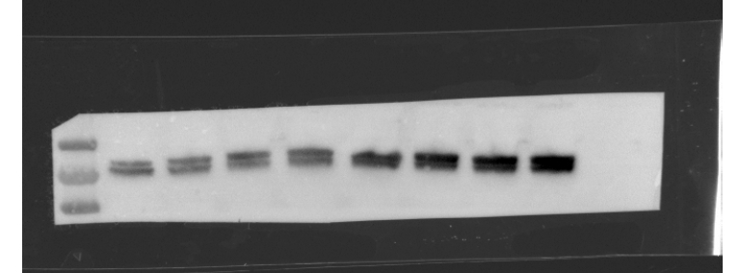
55KD
70KD
100KD
Maker ctrl 25 50 100 150 200 300 400

GAPDH
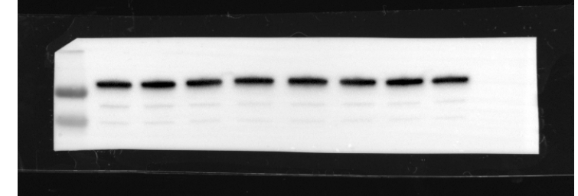
25KD
35KD
Maker ctrl 25 50 100 150 200 300 400

Fig. 2
FN
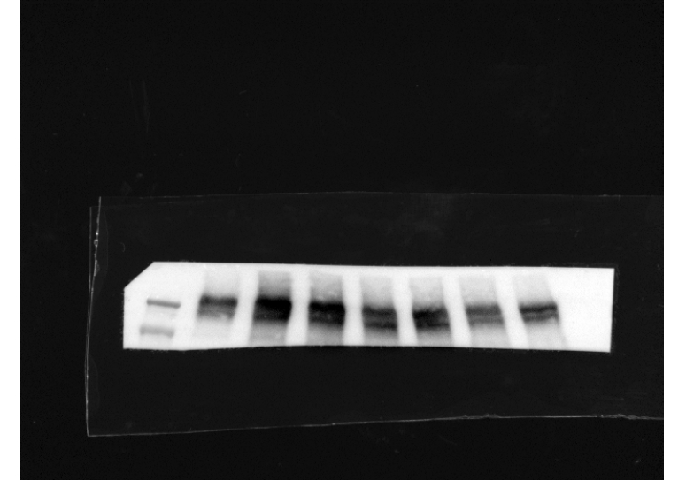
250KD
130KD
TGF β(ng/mL) 0 10 10 10 10 0 0

TM(ng/mL) 0 0 100 200 300 100 200

α-SMA
TGF β(ng/mL) 0 10 10 10 10 0 0

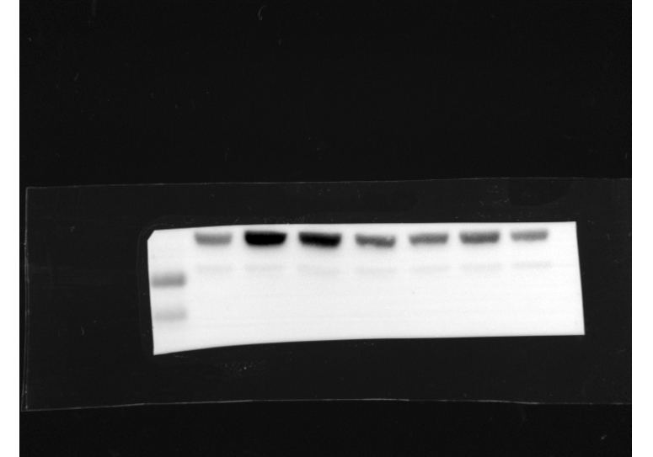
35KD
25KD
TM(ng/mL) 0 0 100 200 300 100 200

Occludin
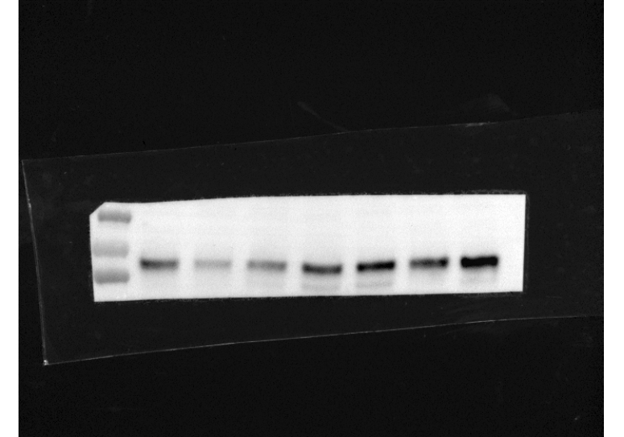
100KD
70KD
55KD
TGF β(ng/mL) 0 10 10 10 10 0 0

TM(ng/mL) 0 0 100 200 300 100 200

Grp78
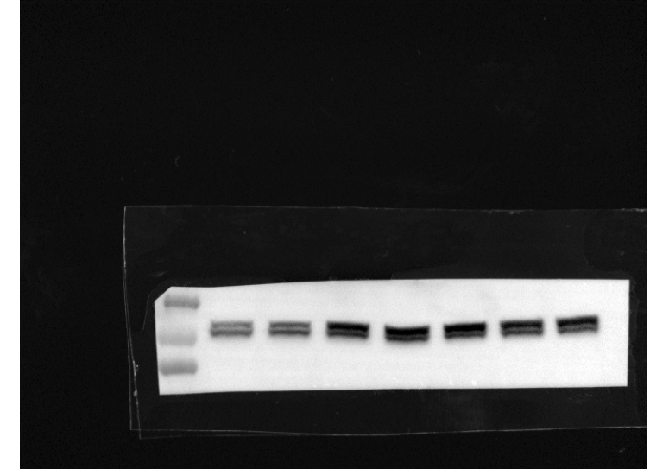
55KD
70KD
100KD
TGF β(ng/mL) 0 10 10 10 10 0 0

TM(ng/mL) 0 0 100 200 300 100 200

GAPDH
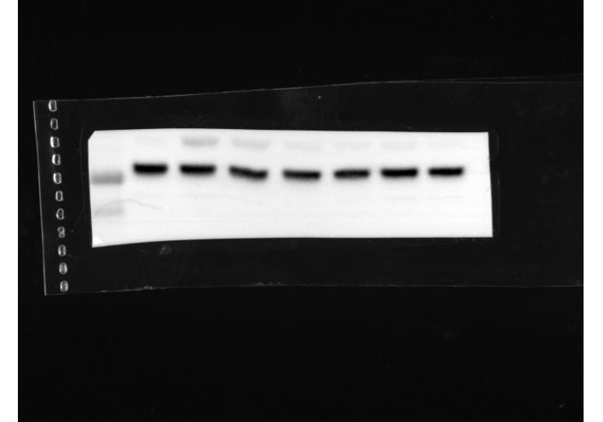
25KD
35KD
TM(ng/mL) 0 0 100 200 300 100 200

TGF β(ng/mL) 0 10 10 10 10 0 0

Fig. 3
TGFBR2
TGF β(ng/mL) 0 0 10 10

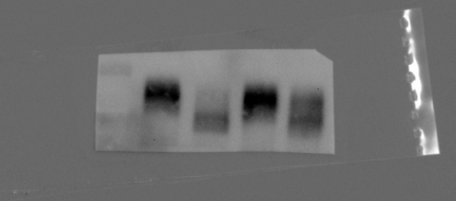
TM(ng/mL) 0 100 0 100

100KD
70KD
55KD
p- TGFBR2
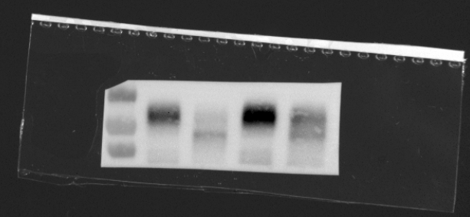
TM(ng/mL) 0 100 0 100

TGF β(ng/mL) 0 0 10 10

100KD
55KD
70KD
Smad2/3
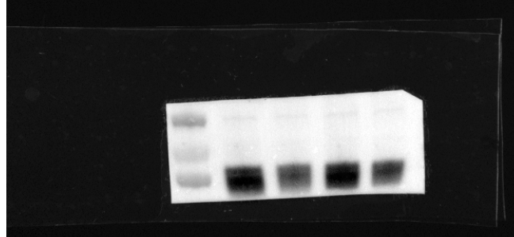
TGF β(ng/mL) 0 0 10 10

TM(ng/mL) 0 100 0 100

55KD
70KD
100KD
p-Smad2/3
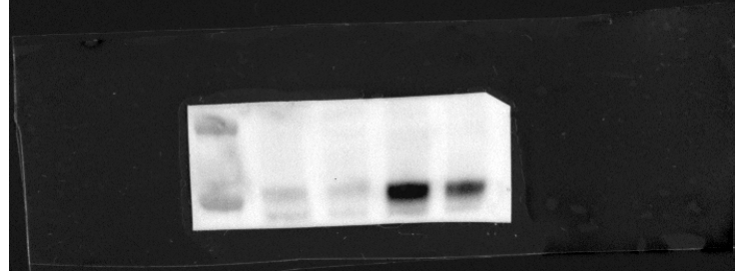
TGF β(ng/mL) 0 0 10 10

TM(ng/mL) 0 100 0 100

55KD
100KD
70KD
Grp78
TGF β(ng/mL) 0 0 10 10

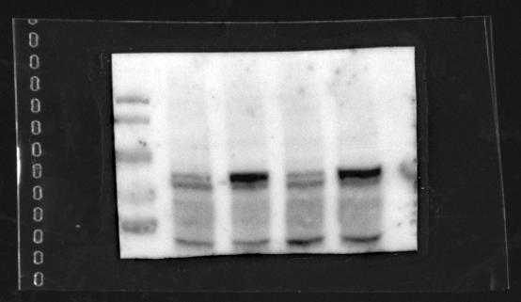
TM(ng/mL) 0 100 0 100

180KD
130KD
100KD
55KD
70KD
GAPDH
TGF β(ng/mL) 0 0 10 10 Maker 0 0 10 10

